ASSIGNMENT # 3

PART A:

(1)

STRUCTURAL MODEL OF ONLINE BANKING SYSTEM:

The Unified Modelling Language (UML) can be used to represent the structural model of an online banking system. To model the system's structure, UML offers a collection of diagrams. In this instance, the classes, properties, and methods of the system will be represented using class diagrams. To describe the system's use cases, we will also employ use case diagrams.

Use Case Diagram:

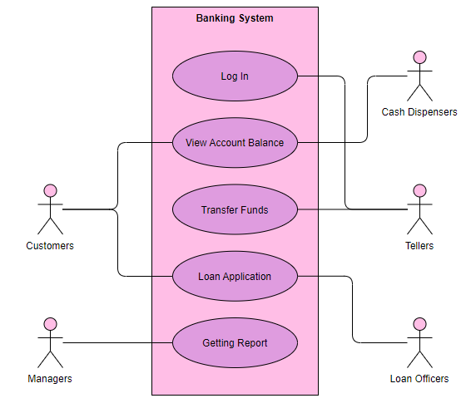

An online banking system can be put to use in the following scenarios:

Login:

The user enters their username and password to log into the system.

Check Account Balance:

The user has access to check their account balance.

Transfer Funds:

The user is able to move money between accounts.

Online bill payment is an option for the user. Online users have the option of requesting a replacement card.

Change Password:

Users are able to modify their passwords.

The user has the option to view their transaction history.

Logout:

The user exits the application.

Class Diagram:

An online banking system can be divided into the following categories:

User:

This class stands in for the system's user. Name, username, password, email, and phone number are some of its properties.

Account:

The user's account is represented by this class. Account number, account type, balance, and status are some of its characteristics.

Transaction:

This class represents user-made transactions. It includes details like the transaction ID, amount, description, and the date and time.

Bill:

The bills that can be paid through the system are represented by this class. It provides details like the name, amount, due date, and bill ID.

Card:

The user's card is represented by this class. Card number, card type, expiration date, and status are some of its properties.

For the classes, the following techniques can be identified:

User:

This class has methods for logging in, logging out, changing passwords, and viewing transaction histories.

Account:

This class has methods for viewing account balances, transferring money, and viewing transaction histories.

Transaction:

Because it only represents one transaction, this class has no methods.

Bill:

This class's methods include seeing bill data and paying a bill.

Card:

This class has two methods: see card details and request a new card.

The following diagram illustrates the relationships between the classes:

A user may have several accounts.

One user owns the account.

A transaction can be one or multiple in an account.

Bill could be connected to a single account or several.

A card may be linked to a single account.

The User, Account, Transaction, Bill, and Card classes are all included in the overall structural model of an online banking system. These classes contain characteristics and methods that correspond to the system's functionality. The User class methods describe the use cases and give a clear picture of how the system is utilized by the end users.

(2)

Sequence, state, and activity diagrams can all be used to depict the dynamic model of an online banking system. In this instance, we'll use state diagrams to describe the states of the objects, activity diagrams to represent the flow of system operations, and sequence diagrams to represent the flow of messages between objects.

Sequence diagram:

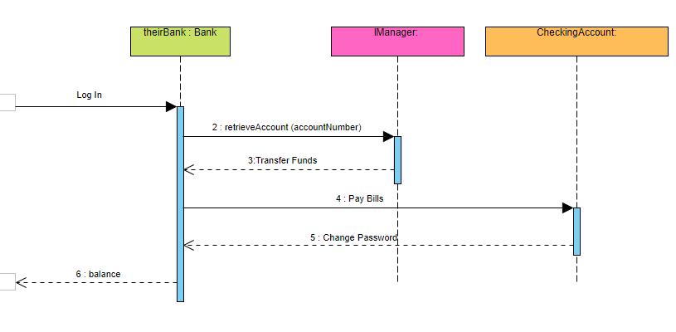

Login:

A login request is sent to the system by the user. After confirming the user's credentials, the system replies to the user.

View Account Balance:

Sending a request to view one's account balance is done by the user. The system sends the user the account balance after retrieving it.

Transfer Funds:

The user submits a request for a fund transfer. The computer checks to see if the user has enough money and then notifies them via SMS. If the user agrees, the system takes the money out of their account and sends it to the designated account.

Pay Bills: A request to pay a bill is sent by the user. The computer collects the bill information and notifies the user via message. The system takes the money out of the user's account and marks the bill as paid if they agree.

User sends request for new card: User sends request for new card. A fresh card is created by the system and sent to the user.

Change Password: The user submits a password change request. The user is prompted by the system to input their new password, and their existing password is updated.

The user requests to view their transaction history by sending a request. The user receives the transaction history that the system has retrieved and sent to them.

State Diagram:

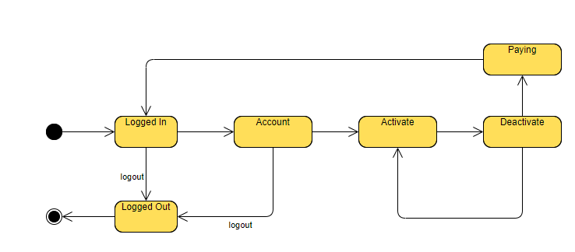

User:

The states of the User object are Logged In and Logged Out.

Account:

There are three states for the Account object: Active, Inactive, and Overdrawn.

Bill:

There are two states for the Bill object: Paid and Unpaid.

Activity Diagram:

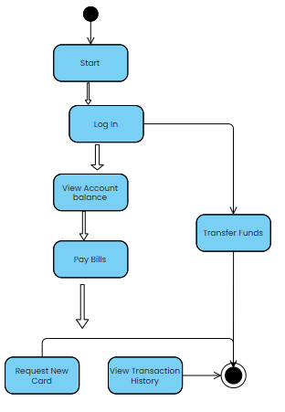

Log In:

Users must log in by providing their username and password. If the credentials are valid, the system verifies them and logs the user in.

View Account Balance:

Requesting to view their account balance, the user makes this request. The account balance is retrieved by the system, which then shows it to the user.

Transfer Funds:

The user asks to send money. The user is prompted by the system to provide the recipient's account number and the amount. The computer checks to see if the user has enough money and then asks them to confirm the transaction. The system takes the money out of the user's account and sends it to the recipient's account after the user confirms.

Bill Payment:

The user asks to pay a bill. The user is prompted to choose the bill and enter the amount by the system. The system obtains the bill information and requests confirmation of the transaction from the user. The system takes the money out of the user's account and marks the bill as paid if they agree.

User Requests New Card:

The user asks for a new card. A fresh card is created by the system and sent to the user.

Change Password:

The user wants a password change. The user is prompted by the system to input both their old and new passwords. If the user's old password is valid, the system updates it.

User Requests to View Transaction History:

The user asks to view their transaction history. The user's transaction history is retrieved by the system and shown to them.

The dynamic model of the online banking system as a whole consists of activity diagrams to describe the flow of system activities and state diagrams to represent the states of the objects. Sequence diagrams are used to depict the flow of messages between objects. The system's behavior when a user interacts with it is clearly understood thanks to the dynamic model.